TITLE (Capital letter, Bold, Arial, 18p)

# Surnames, Names #1 [1]*, Surnames, Names #2 [2], Surnames, Names #3 [1,2]

# (Bold, Arial, 12p)

[1] Affiliation and address (name of company/institution, street, city, state)

[2] Affiliation and address (name of company/institution, street, city, state)

(Arial, 10p)

\****Corresponding Author***: email address

# ABSTRACT (Capital letter, Bold, Arial, 12p)

For the preparation of the extended abstracts of oral and poster presentations, the authors are asked to use the present document as a template and follow the recommendations mentioned below.

The extended abstract should be 2 - 4 pages long, including figures and tables. It must be written in English and provide key elements of your research or design, technical approaches and outcomes or main conclusions.

Paragraphs should be typeset in block mode, 11 pt, with left and right indents of 3 cm. Use Arial Typeface.

Figures and tables must be included as in the examples below.

**Table 1: Cities where HotLab meeting took place (Bold, Arial, 11p)**

|  |  |
| --- | --- |
| HotLab 2021 | Prague |
| HotLab 2022 | Manchester |
| HotLab 2023 | Knoxville |
| HotLab 2024 | Amsterdam |

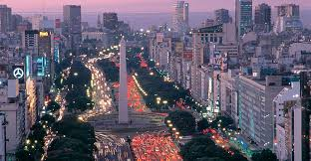

**Figure 1: Obelisk of Buenos Aires (Bold, Arial, 11p)**

Send your extended abstract file by e-mail to [hotlab2025@cnea.gob.ar](mailto:hotlab2025@cnea.gob.ar), in pdf format, name it as ***HL2025_Surname first author*** and write ***Extended*** a***bstract submission*** in the subject box.

**Keywords:** Four to five keywords